# CLASS: F.Y. MCA SEM: I

**COURSE CODE: MC504 SUBJECT NAME: WEB TECHNOLOGY LAB**

# ROLL NO. 2022510059 BATCH: D

**NAME: CHAITANYA SHETTY EXPERIMENT NO: 08**

**EXPERIMENT TITLE**: Write a program to add two numbers using rest api and express js.

# Objective:

In this web app, there is only going to have one client side html file and two server side node.js files. The html file will have two forms. One with GET method that submits a name to the server and the server will respond with a greeting message. The other form with POST method that submits two numbers to the server and the server will respond with the sum of the two numbers.

Index.html

<!DOCTYPE html>

<html lang="en">

<head>

  <meta charset="UTF-8">

  <meta http-equiv="X-UA-Compatible" content="IE=edge">

  <meta name="viewport" content="width=device-width, initial-scale=1.0">

  <title>Simple Node App Template</title>

</head>

<body>

  <form action ="/svc/greeting" method="GET">

    <input name="firstname" type="text" placeholder="First Name">

    <button type="submit"></button>

  </form>

  <br>

  <form action="/svc/add" method="POST">

    <input name="num1" type="number">

    <span>PLUS</span>

    <input name="num2" type="number">

    <button type="submit">Button</button>

  </form>

</body>

</html>

Server.js

var express=require('express'),

bodyParser=require('body-parser'),

app=express(),

service=require('./service.js');

app.use(bodyParser.json());

app.use(bodyParser.urlencoded({

  extended:true

}));

app.use(express.static('../public'));

service.attachService(app);

app.listen(3333);

console.log("server at http://localhost:3333");

service.js

function greeting(req,res){

  var fn = req.query.firstname;

  res.send("Greetings " +fn);

}

function addition(req,res){

  var n1 = req.body.num1,

  n2 = req.body.num2,

  sum = parseInt(n1) + parseInt(n2);

  res.send(n1 + ' plus ' + n2 +' is equal to '+ sum);

}

var attachService = function(app){

  app.get('/svc/greeting',greeting);

  app.post('/svc/add',addition);

};

exports.attachService=attachService;

localhost:3333/svc/greeting

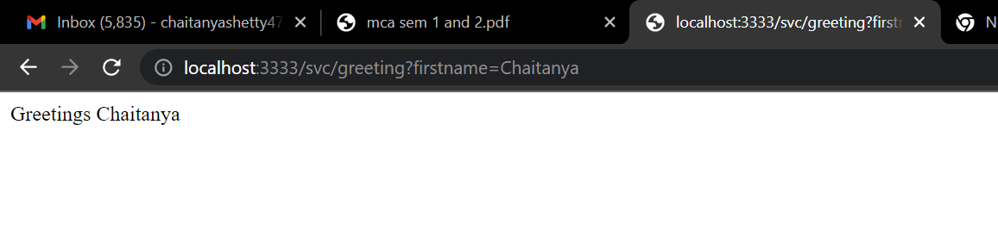

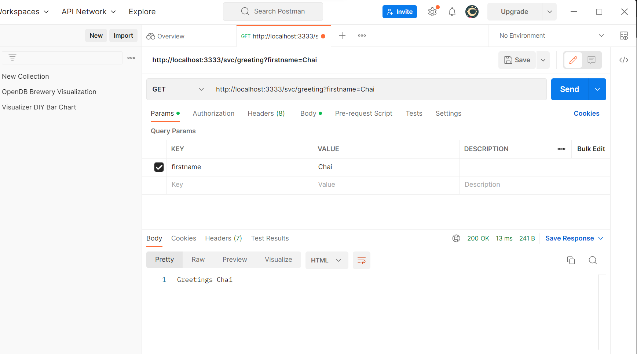

localhost:3333/svc/add

